Title
Inventory Management System Using Spring Boot and MongoDB

Summary
The Inventory Management System is a backend application developed using Java, Spring Boot, and MongoDB. The system manages products, categories, suppliers, and inventory-related information. CRUD operations can be performed through both a console-based menu and REST APIs. MongoDB is used as the database for storing and retrieving data, while Postman is used to test API endpoints.
The project also implements validation checks, automatic supplier-product mapping, and inventory reports such as products by category and low stock products.

Tools Used
Tool | Version
Java | 21
Spring Boot | 3.5.15
MongoDB Server | 8.0.24
MongoDB Compass | 1.49.8
Maven | 3.8.7
Postman | Latest Version
IntelliJ IDEA Community Edition | Latest Version

Outcome
The developed system successfully provides:
- Product Management
- Category Management
- Supplier Management
- Automatic Product-Supplier Mapping
- Inventory Reports
- Data Validation
- MongoDB Integration
- REST API Support
- Console-Based Operations
The application enables efficient inventory management while maintaining data consistency through validation rules.

Project Architecture
The application follows a layered architecture:
Console Menu / Postman
↓
Controller Layer
↓
Service Layer
↓
Repository Layer
↓
MongoDB Database

Controller Layer
Handles incoming API requests.

Service Layer
Contains business logic and validation.

Repository Layer
Communicates with MongoDB collections.

Database Layer
Stores application data.

REST APIs Implemented

Product APIs
GET /api/products
GET /api/products/{id}
POST /api/products
PUT /api/products/{id}
DELETE /api/products/{id}

Category APIs
GET /api/categories
GET /api/categories/{id}
POST /api/categories
PUT /api/categories/{id}
DELETE /api/categories/{id}

Supplier APIs
GET /api/suppliers
GET /api/suppliers/{id}
POST /api/suppliers
PUT /api/suppliers/{id}
DELETE /api/suppliers/{id}

Product Supplier APIs
GET http://localhost:8080/api/product-suppliers

Report APIs
GET /api/reports/products-by-category/{categoryId}
GET /api/reports/low-stock-products
GET /api/reports/products-by-supplier/{supplierId}

Screenshots

Screenshot 1 – Console Menu
The console menu that we will use to interact with the database
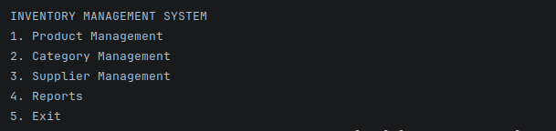

Screenshot 2 – MongoDB Compass
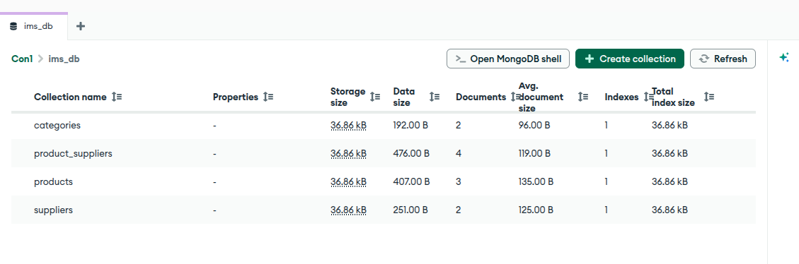
Screenshot 3 – Project Structure
The console menu that we will use to interact with the database
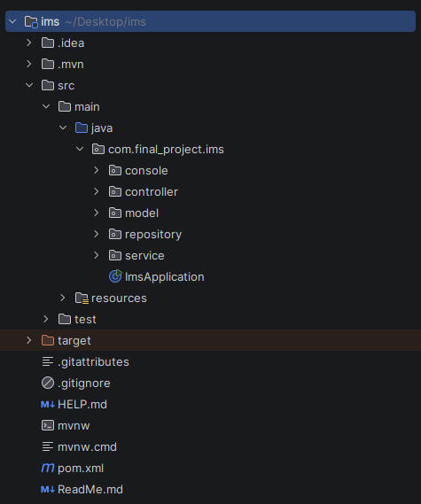

Screenshot 4 – Category CRUD Operation
Creating 3 Categories – Electronics, Grocery, and Stationary
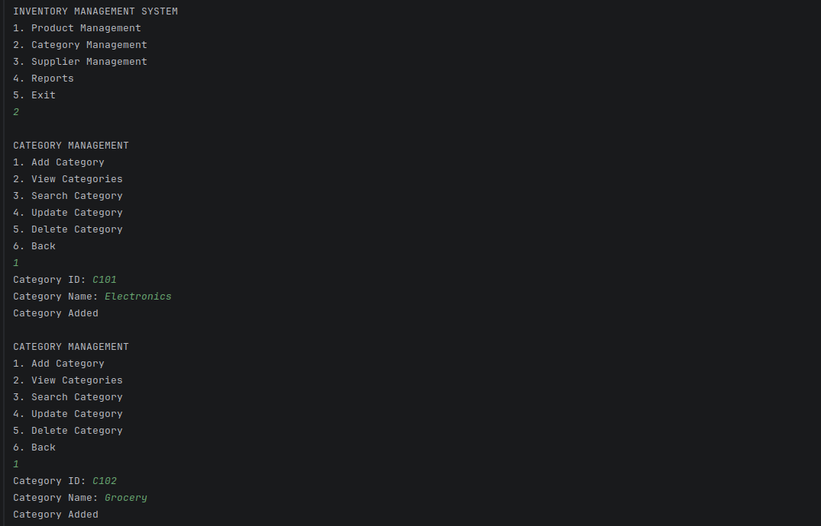

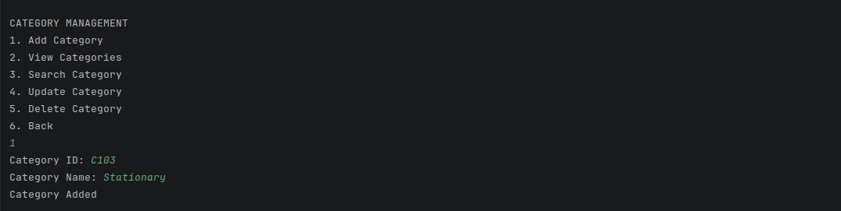

Reading or Finding the records in Category
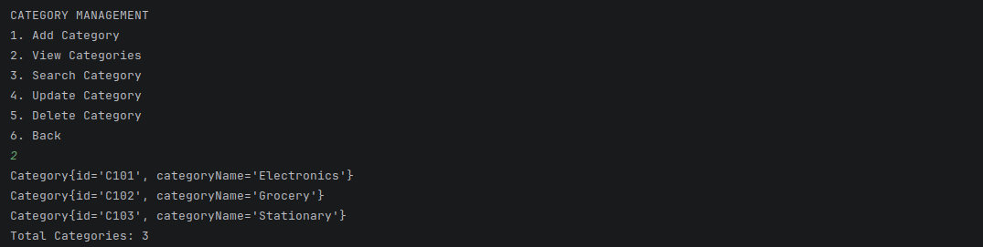
Updating Staionary record to School Stuff
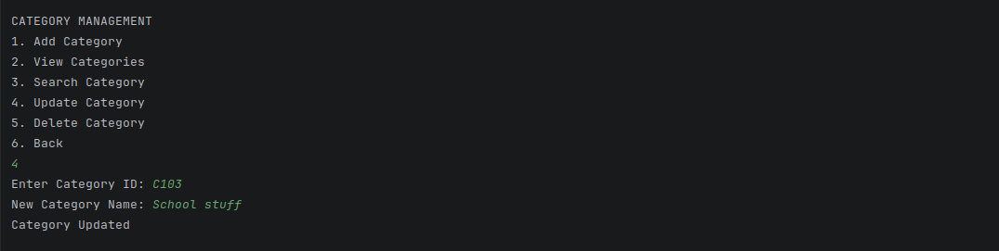
Deleting School stuff record
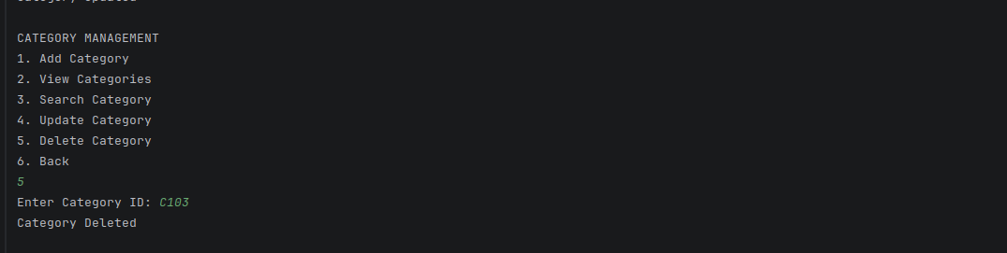

Screenshot 5 – Product CRUD Operation
Creating 4 records – Laptop, Mouse, Rice, and Ghee

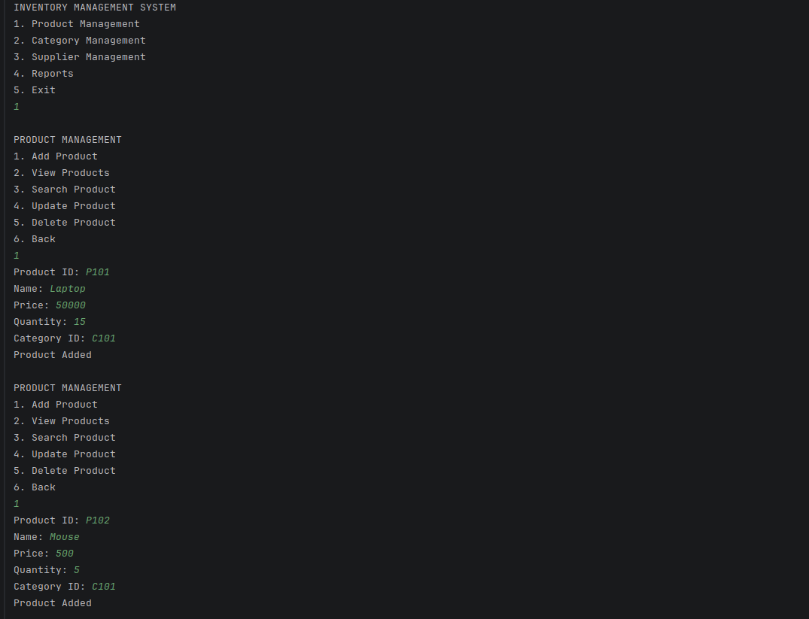

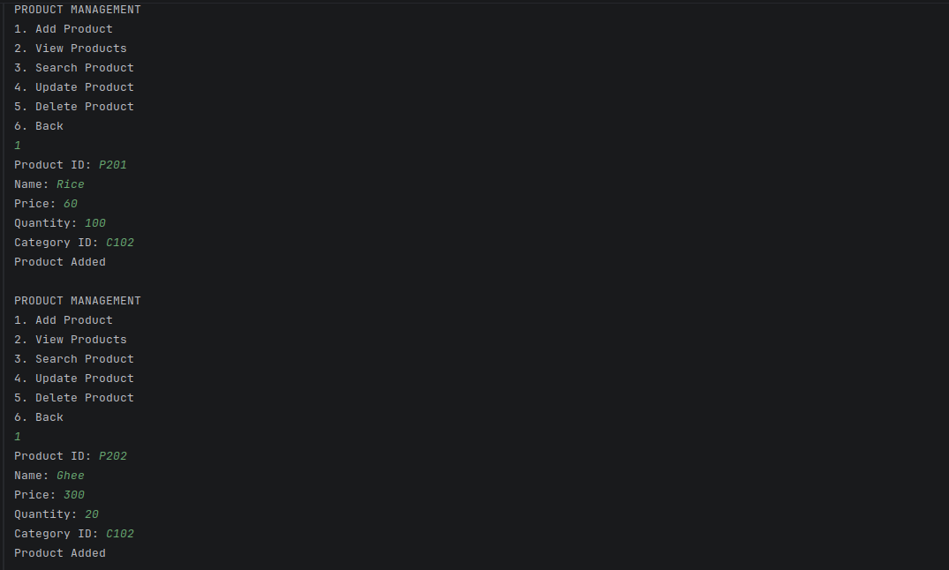

Reading or Finding the records in Products Collection
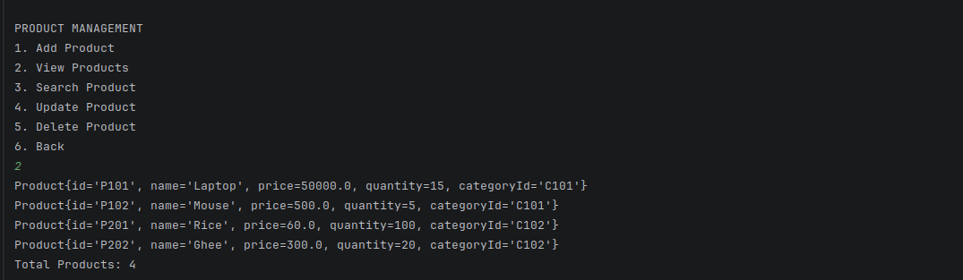
Updating laptop to gaming laptop
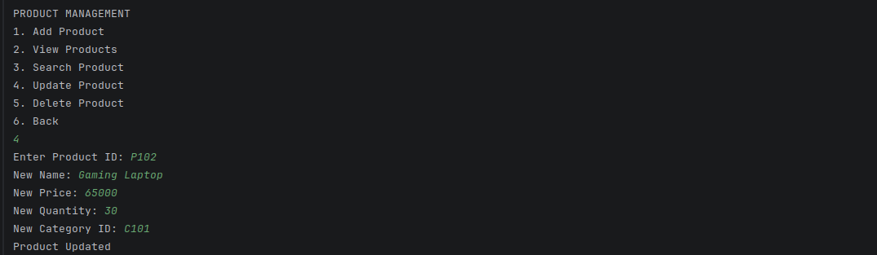
Deleting Ghee record
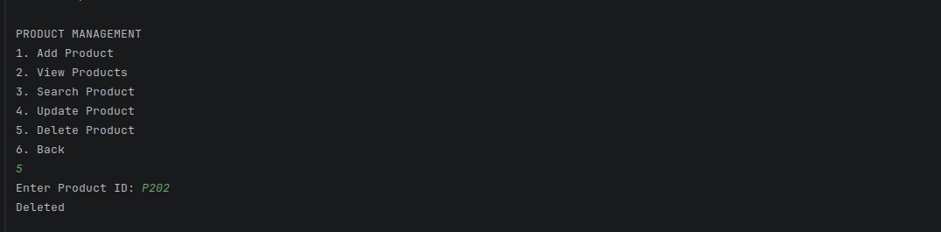

Screenshot 6 – Supplier CRUD Operation
Creating 3 Suppliers – ABC, XYZ, and GIF
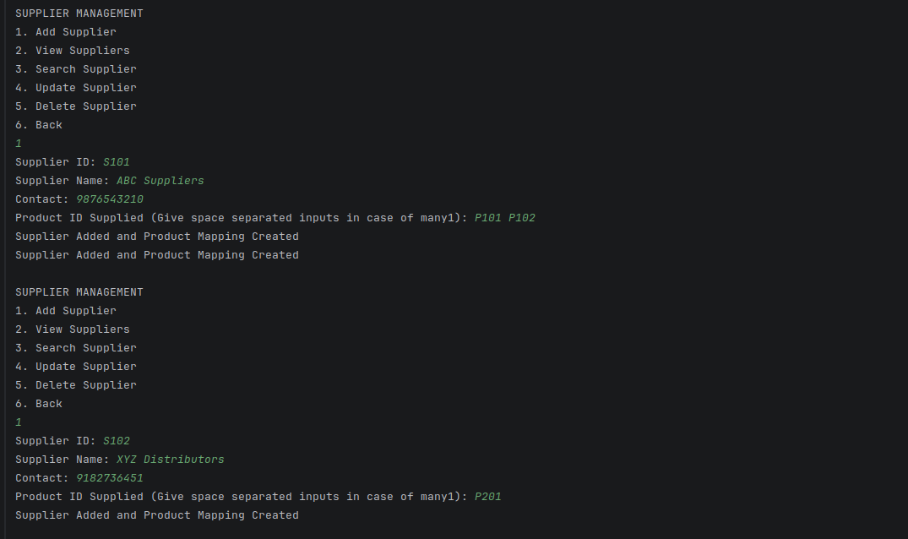
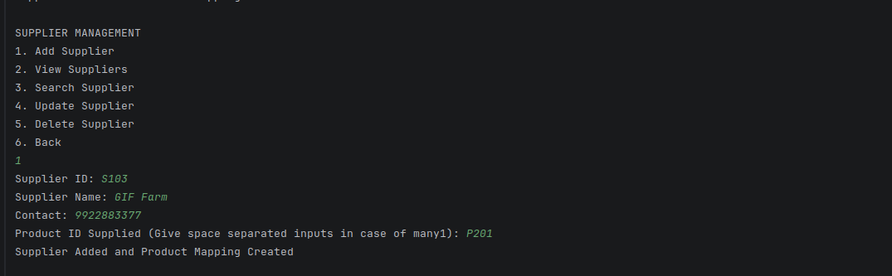
Reading or Finding the records in Supplier
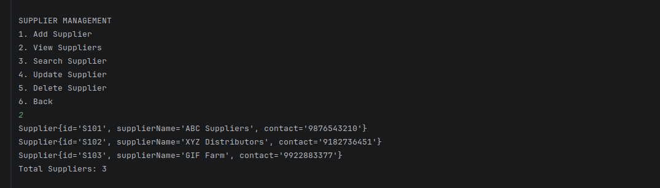
Updating GIF Farm to GEE Farms
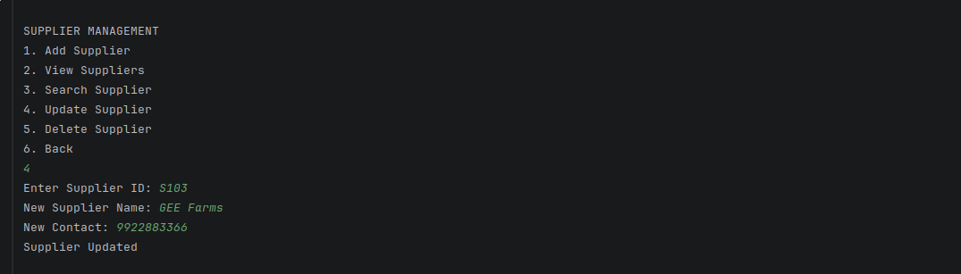
Deleting GEE Farms
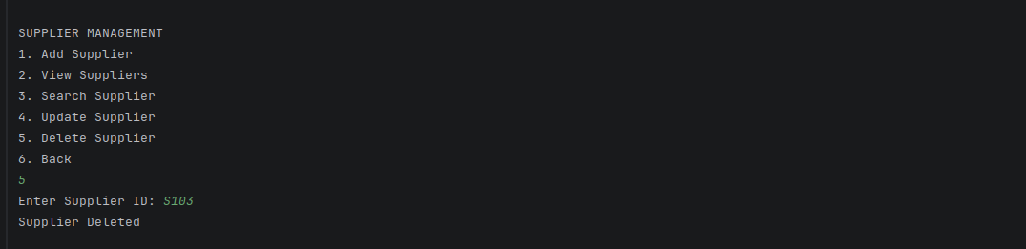

Screenshot 7 – Products By Category Report
Showing the product connected to a particular category
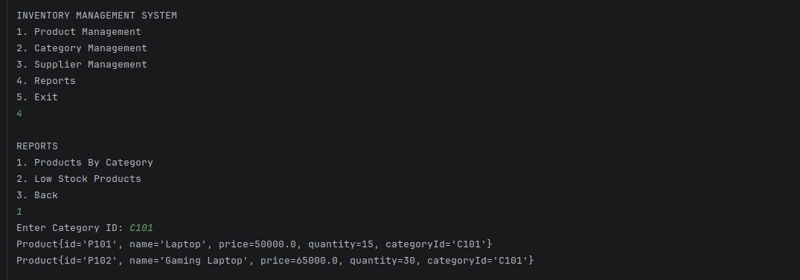

Screenshot 8 – Low Stock Products Report
Finding stocks with less than 10 quantity
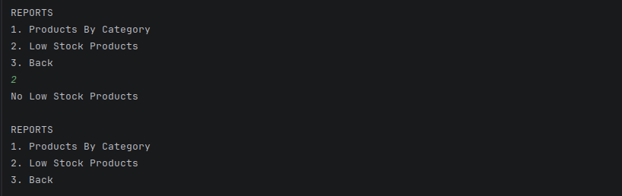

Screenshot 9 – Postman Product API
Quering products collection through Postman
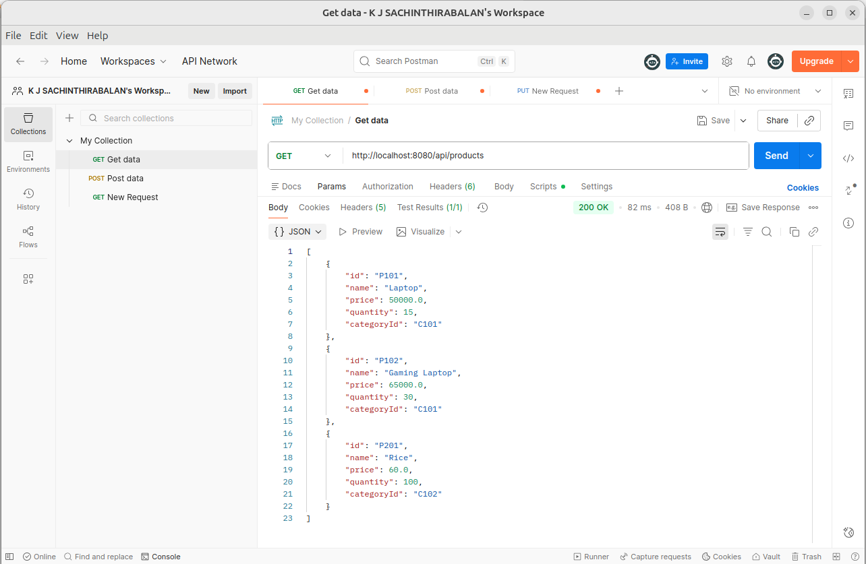

Screenshot 10 – Postman Category API
Quering category collection through Postman
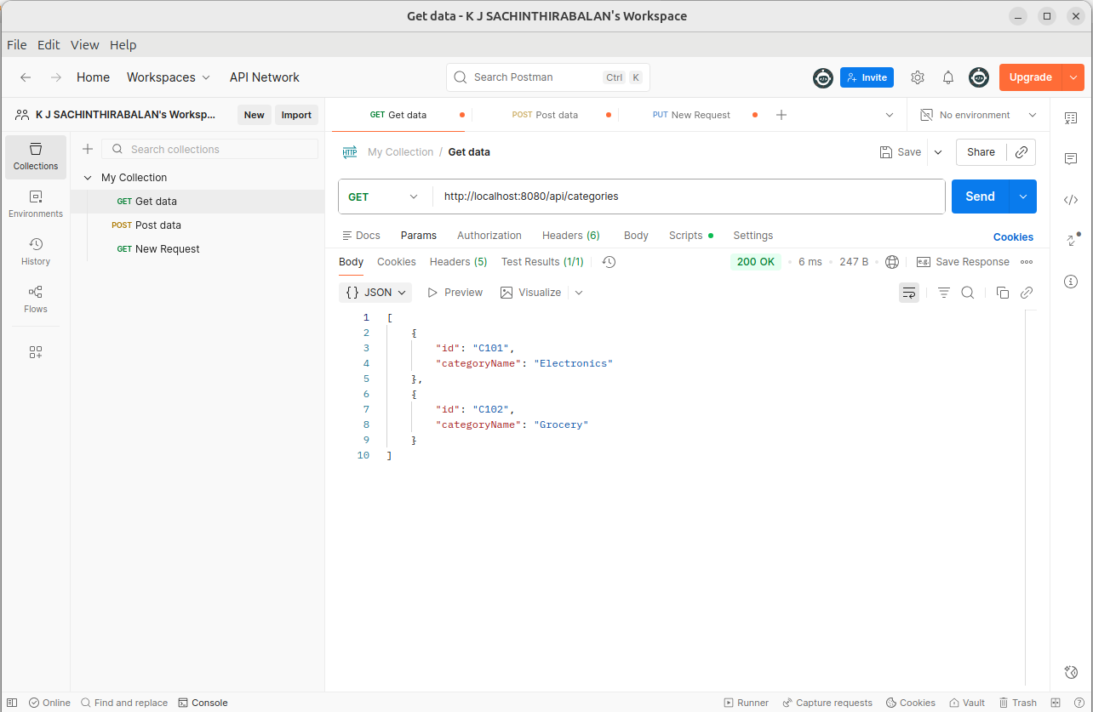

Screenshot 11 – Postman Supplier API
Quering supplier collection through Postman
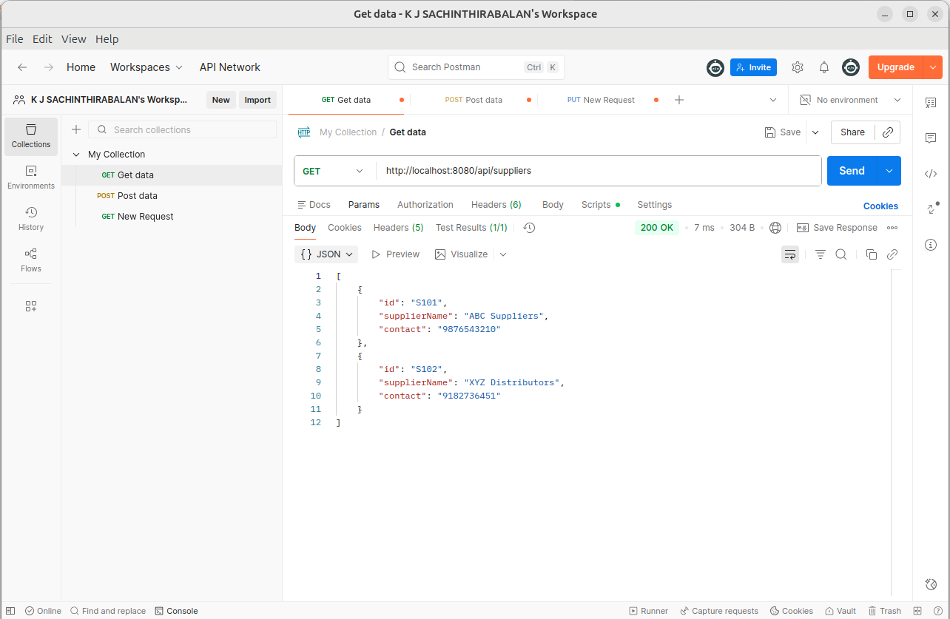

Screenshot 12 – Products and Suppliers Mapping API
Quering product-supplier collection through Postman
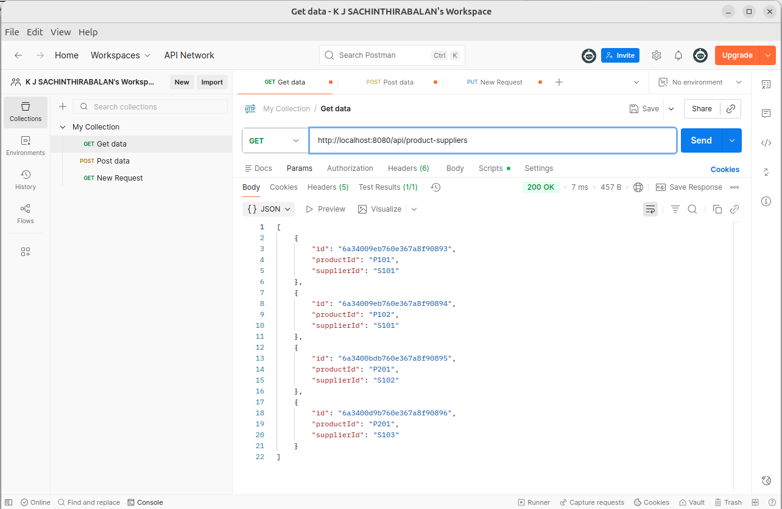

Conclusion
The Inventory Management System was successfully developed using Java, Spring Boot, and MongoDB. The application supports inventory management through both REST APIs and a console-based interface. The project demonstrates CRUD operations, data validation, MongoDB integration, automatic relationship management, and report generation.
The implementation provides a practical understanding of backend development concepts including layered architecture, RESTful web services, NoSQL databases, and Spring Boot application development.

